|  |
| --- |
|  |
| SMART PARKING Using IoT |
|  |

|  |
| --- |
| Submitted by,    SRIVARUDAN J  au812921106033  srivarudan@gmail.com |

INTRODUCTION

Internet of thing (IoT) has the ability to transfer data through network without involving human interactions. IoT allows user to use affordable wireless technology and also helps the user to transfer the data into the cloud. IoT helps the user tomaintain transparency. The idea of IoT started with theidentity of things for connecting various devices. These devices can be controlled or monitored through computers over internet. IoT contains two prominent words “Internet”and “Things”,

According to the recent survey, there will be a rapid increase in the vehicle’s population of over 1.6 billion around 2035 [7]. Around one million barrels of world’s oil is being burnt everyday [4]. Thus, smart parking system is the key solution to reduce the waste stage of the fuel. The solution for the problems that is being raised.

SYSTEM ARCHITECTURE

## A. Proposed System

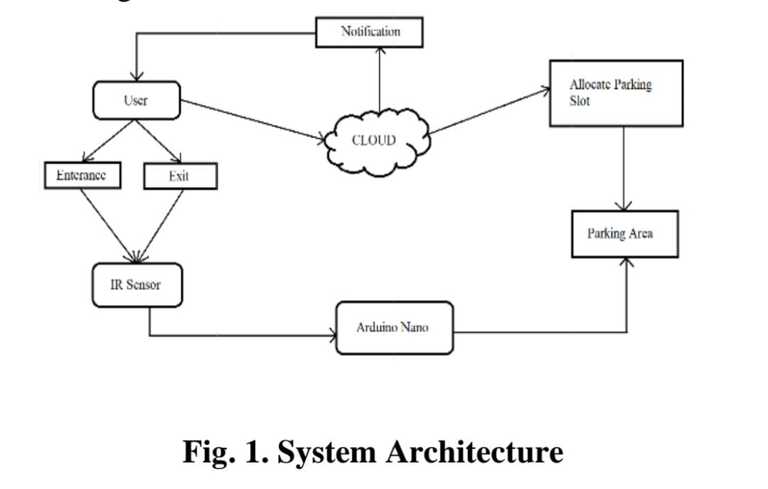 First section is the parking area which includes Arduino devices along with IR sensor. The user interacts with the parking area with the help of these devices. The user cannot enter the parking area without the help of RFID card. The second section contains the cloudbased

## b. Hardware

The three main hardware components used are GMS module, RFID card, IR sensors. A user is allowed inside a parking space only if the user has a RFID card. RFID card contains the information of the registered user. As the car enters the parking slot, reader module scans the registeredthe availability of the car parking and simultaneously, the User is notified through SMS about the status of the parking area.

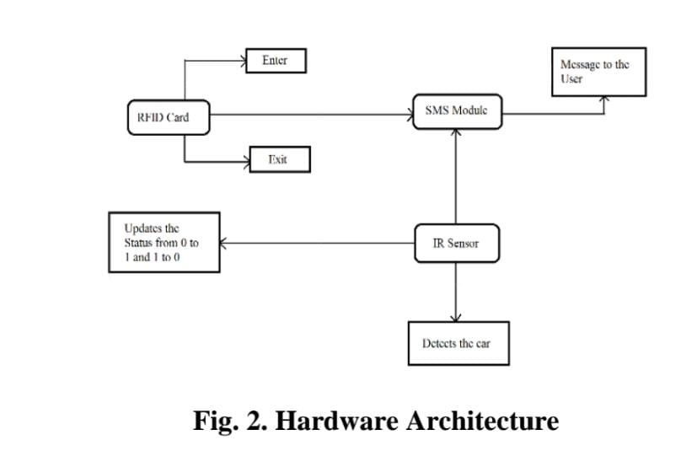

## C. Software

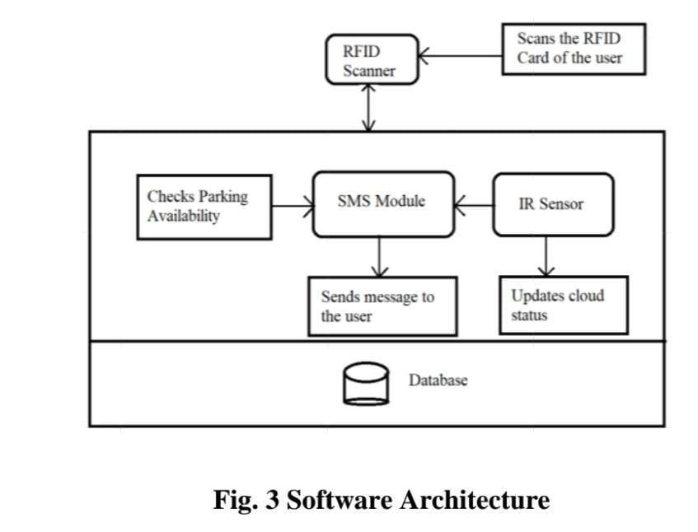 The cloud server acts as a mediator between the modules. The cloud server is connected to the Wi-Fi module. The user receives messagesthrough the SMS module while the car enters and exits the parking area using RFID card. The messages sent by the SMS module are managed by the cloud. As soon as the IR sensor detects the car, the status of the cloud will be updated from 0 to 1 and when the car leaves the parking area the status of the car will be updated from 0 to 1.

Components

* GSM module
* IR sensor
* RFID card
* READER module
* SERVO motor
* Arduino Nano
* WIFI module

## GSM Module

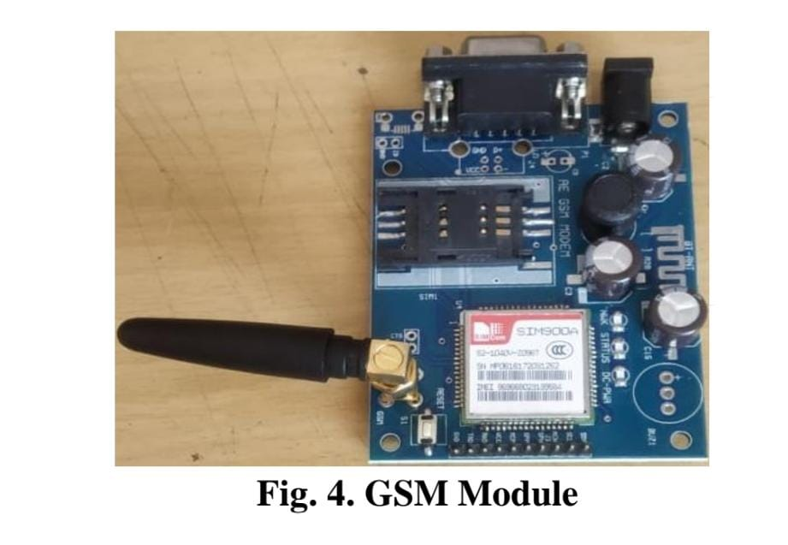 The GSM module is a circuit which is used to setucommunication between mobile phones and microcontroller. It is used to send SMS, MMS and voice messages through mobile network. GPRS extension in GSM allows high data transmission. GSM uses time division multiple access approach for transmission.

## IR Sensor

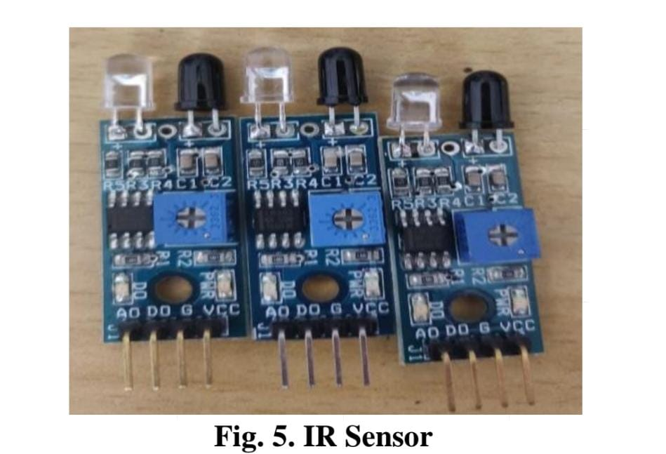 An infrared sensor is basically an electronic device which is used to detect the presence of objects. Infrared light is emitted by this device. If this device does not detect any IR light reflected back that means there is no object present. If the light is detected by the sensor there is an object present.

## RFID Card

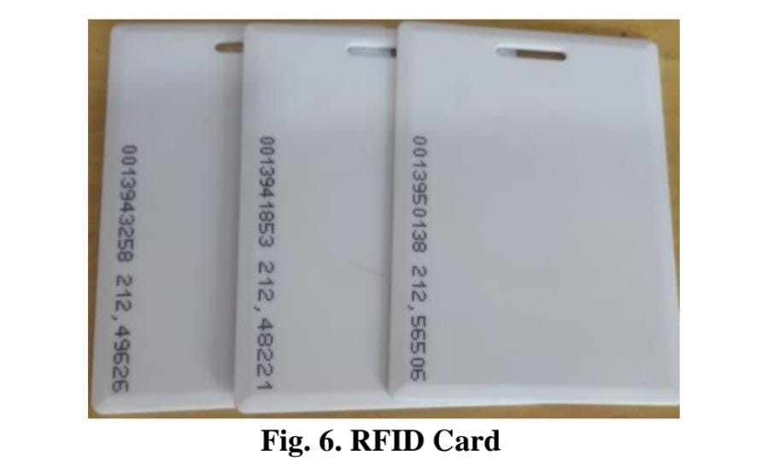 RFID tags are made up of integrated circuit (IC), an antenna, and a substrate. It is an identification badge or credit card that transfers its contents about an object to the Reader module. RFID tag transfers data about an object through radio waves.When RFID tags are attached to devices they can also be used for tracking.

## READER Module

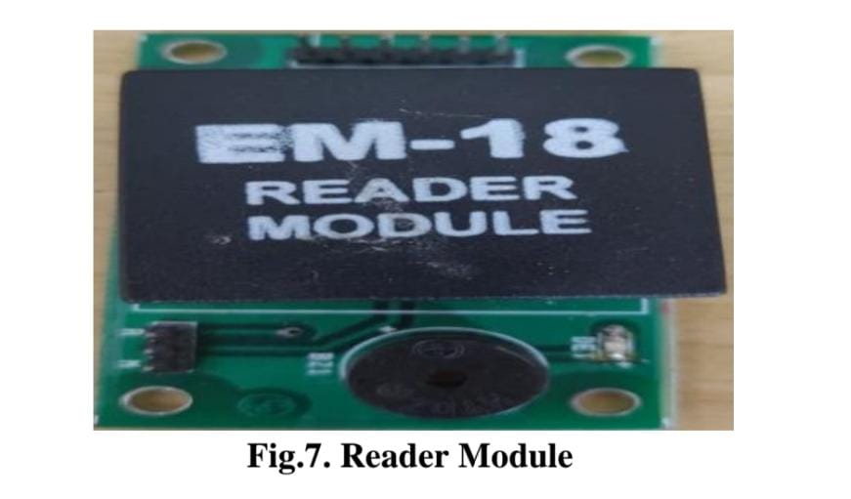 This module is a device which scans and gathers the information from the RFID Card. This card can be used to track objects. As the car enters the parking area, the user scans the RFID card and all the information stored in card is transferred to the admin through this module.

## Servo Motor

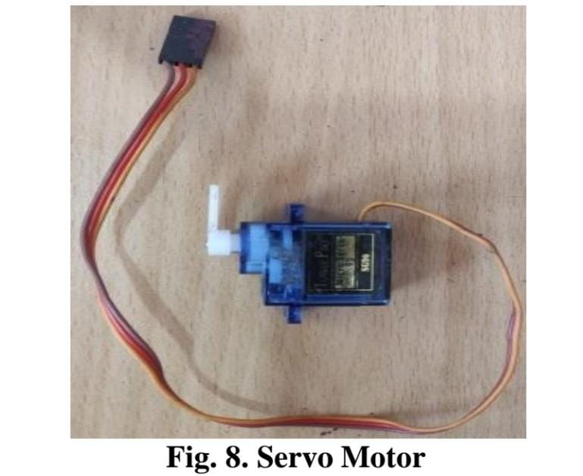 It is a rotator device that allows the control of angular as well as linear motion. A servo motor is used for the opening and closing of the gate. Servo drivetransmits electrical signals to the servo motor for producing motion.

## Arduino Nano

It is a compact board which can be used in various devices and various field. It has overall 22 input/output pins out of which 14 pins are digital pins. It has a flash memory of

about 32 kb. These pins can control the operations of digital pins as well as analogy pins. This module is a breadboard friendly board which can be easily used anywhere.

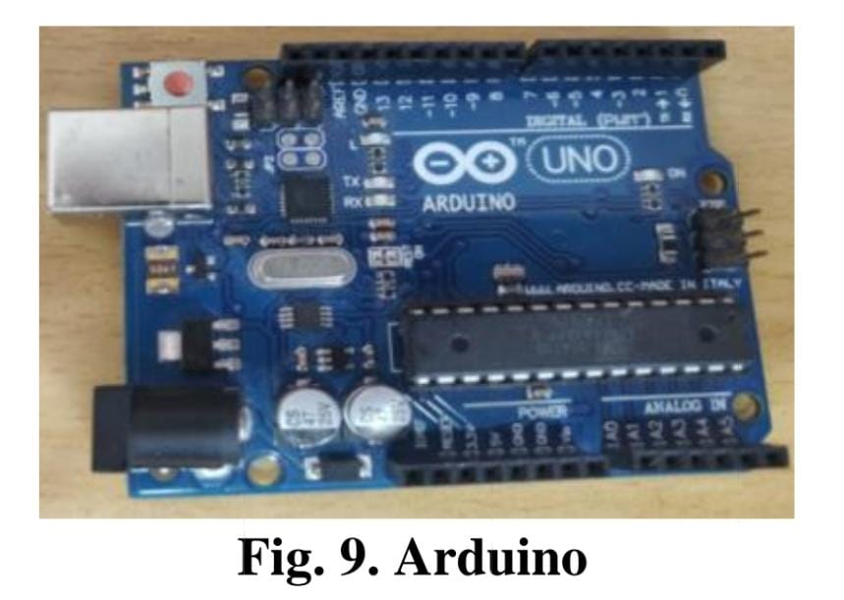

## WIFI Module

It is used to send data from embedded system to the internet using URL by HTTP POST method using TCP/IP protocol. It is developed by espressif systems. It is a 32 bit

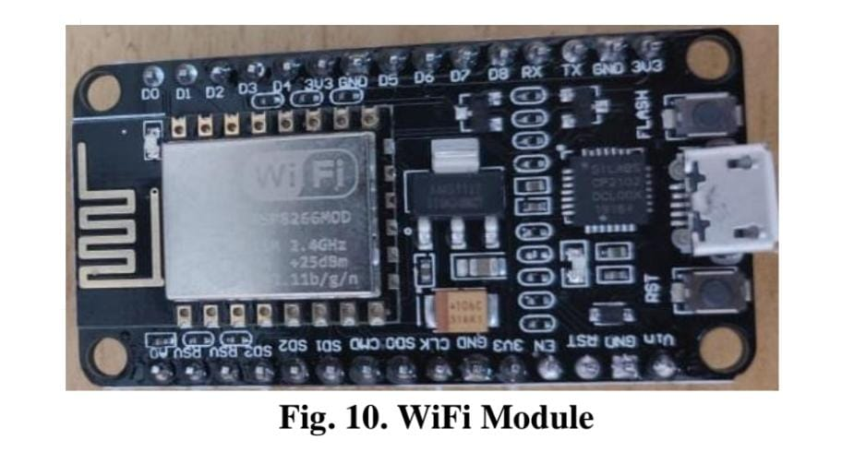microcontroller with 80kb user data. It contains 16 gpio pins.

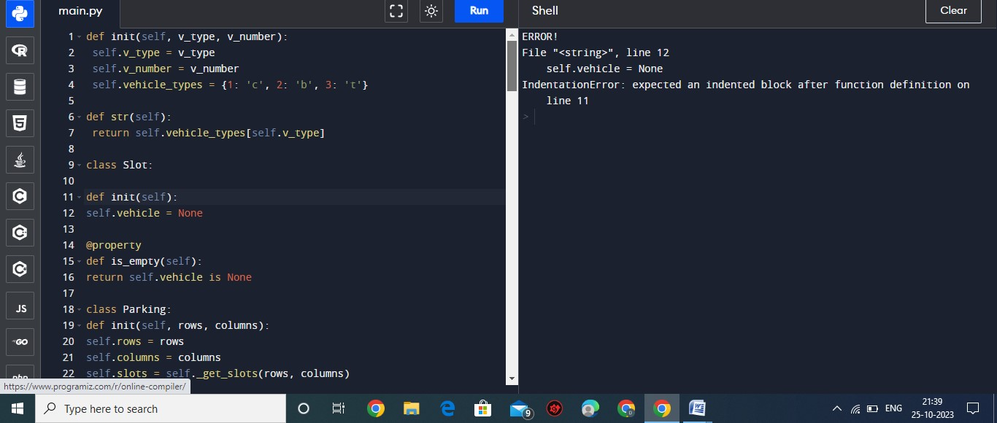program

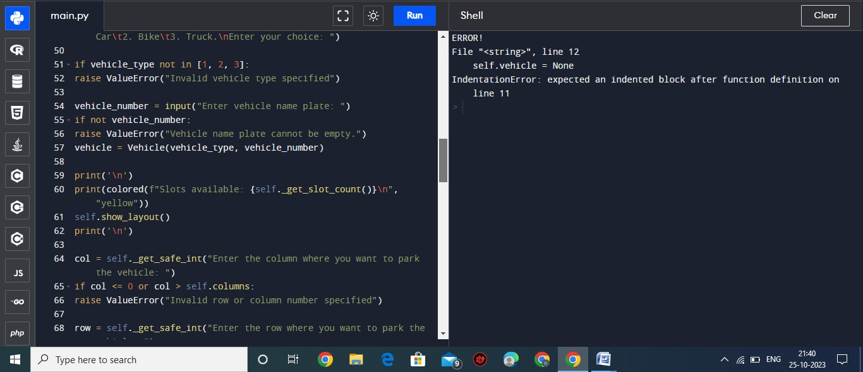

output